Chemistry 20

Lesson 17 – Solubility

The ability of one compound to dissolve in another compound is called **solubility**. The term solubility can be used in two senses, qualitatively and quantitatively. Qualitatively, the term solubility is used in a relative way to describe whether one substance will dissolve in another. If so, the first is said to be soluble in the second.

# Quantitative solubility

Quantitative solubility, on the other hand, refers to the concentration of a saturated solution. To illustrate, suppose you add some pickling salt (pure sodium chloride) to a jar of water and shake the jar until the salt dissolves. What happens if you continue this process? Eventually some solid salt remains at the bottom of the jar, despite your efforts to make it dissolve. A **saturated solution** is a solution at maximum concentration, in which no more solute will dissolve. If the container is sealed, and there are no temperature changes, no further changes will occur in the concentration of the solution or in the quantity of undissolved solute. The **solubility** of a substance is the **concentration of a saturated solution** of that solute in a particular solvent at a particular temperature. For example, the solubility of sodium sulfate in water at 0°C is 4.76 g/100 mL. If more solute is present, it does not dissolve under ordinary conditions.

A saturated solution produced by dissolving hydrogen chloride gas in water is called concentrated hydrochloric acid. If 46.5 g of hydrogen chloride gas is required to prepare 100 mL of concentrated hydrochloric acid at 25oC, what is the **molar solubility** of hydrogen chloride at 25oC?

first calculate moles second, calculate concentration

 

The molar solubility of hydrogen chloride at 25oC is 12.8 mol/L.

# Factors that affect solubility

Solubility involves many variables, including:

* relative size of solute & solvent particles.
* relative polarity of solute & solvent particles.
* interaction between solute & solvent particles.
* temperature.
* pressure.

## The Effect of the Nature of the Solute & Solvent

Generally, polar solvents will dissolve polar solutes. Similarly, non-polar solvents dissolve non-polar solutes. For example acids, bases, and ionic compounds, which are composed of positive and negative ions, will dissolve in water which is highly polar. These compounds will not dissolve in gasoline because gasoline is not polar. The rule of “**like dissolves like**” is used when evaluating the solubility of **molecular** compounds.

When two liquids will not mix in any proportion they are said to be **immiscible**. For example, some liquids, such as mineral oil, do not dissolve in water at all and form a separate layer.

When two substances will mix homogeneously in all proportions, they are said to be **miscible**. For example, water and ethanol or water and methanol will mix in all proportions with each other. The same is true for gasoline and kerosene and for gaseous oxygen and nitrogen.

## The Effect of Temperature

Because most solutes have a limited solubility in a given amount of solvent at a fixed temperature (i.e. are not miscible), solvent temperature usually has a great effect on solubility. In general:

**Solids in liquids**. An increase in temperature increases the solubility of solids in liquids. For example, the solubility of soap and dirt in hot wash water is greater than in cold wash water. The solubility of sodium chloride at different temperatures is shown to the right.

|  |  |
| --- | --- |
| Temperature | Solubility |
| (°C) | (g/100 mL) |
| 0 | 31.6 |
| 70 | 33.0 |
| 100 | 33.6 |

**Gases in liquids**. An increase in temperature decreases the solubility of gases in liquids; rising temperatures cause gas molecules to leave the liquid. For example, when water is heated (but not boiled) dissolved air escapes, forming bubbles, as it becomes less soluble at higher temperatures.

**Liquids in liquids**. The dissolving of liquids in liquids seldom depends on the temperature of the system. Therefore, no generalisation can be made.

## The Effect of Pressure

Pressure changes have almost no effect on the solubility of solids or liquids in liquids.

However, the solubility of gases in liquids is directly proportional to the pressure of the gas above the liquid. The greater the pressure of the gas, the greater the solubility. For example, when a bottle of carbonated soft drink (which contains dissolved carbon dioxide) is opened, the pressure is decreased and some of the dissolved CO2 bubbles out of the solution.

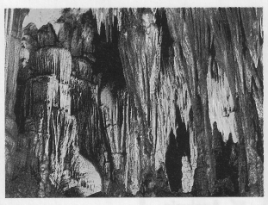Some everyday examples of the effects of changing the conditions of a solution are:

* When water evaporates from a saturated solution, crystallization results. This occurs naturally in the formation of stalactites and stalagmites where dissolved calcium carbonate crystallizes as the water evaporates.
* When you open a bottle or a can containing a carbonated beverage, you lower the gas pressure inside the container. The solubility of the carbon dioxide decreases and some of the dissolved gas comes out of solution.
* If you allow a glass of cold tap water to stand for a while, bubbles form on the inside of the glass since the dissolved air becomes less soluble as the water warms to room temperature.

# Supersaturated solutions

The point at which a solution becomes saturated can change significantly with different environmental factors such as temperature, pressure, and contamination. For some solute-solvent combinations a **supersaturated** solution can be prepared. When dissolving a solid into a liquid, for example, one can raise the solubility by increasing the temperature of the solvent to dissolve more solute, and then lowering the temperature. As the temperature decreases the amount of dissolved solute exceeds the saturation point. A supersaturated solution contains more dissolved solute than the solution can actually maintain. If one were to disturb a supersaturated by either sharply tapping the container or dropping a seed crystal into the solution, excess dissolved solute will suddenly, often spectacularly, crystallize. Check out the following video clips courtesy of youtube:

<http://www.youtube.com/watch?v=7iNG1tTVeyA>

<http://www.youtube.com/watch?v=0wifFbGDv4I&NR=1>

<http://www.youtube.com/watch?v=HnSg2cl09PI&feature=fvw>

<http://www.youtube.com/watch?v=LiHW2-pHi4I&feature=related>

# Solubility of ionic compounds in water

Ionic compounds are always solids at room temperature. If they are placed water, some will readily dissolve and others will not. If a substance dissolves well in water we say it is soluble and we would write (aq) after the chemical formula to indicate that it is dissolved in water (aqua). If a substance does not dissolve well, we say it has a low solubility and we would write an (s) after it to indicate that it remains as a solid in the presence of water. The following **solubility table** may be used to determine whether an ionic compound is soluble in water or not. (Note: The table works for ionic compounds only. The solubility of molecular compounds depends on the “like dissolves like” rule. If a molecular compound is polar it is probably soluble in water.)

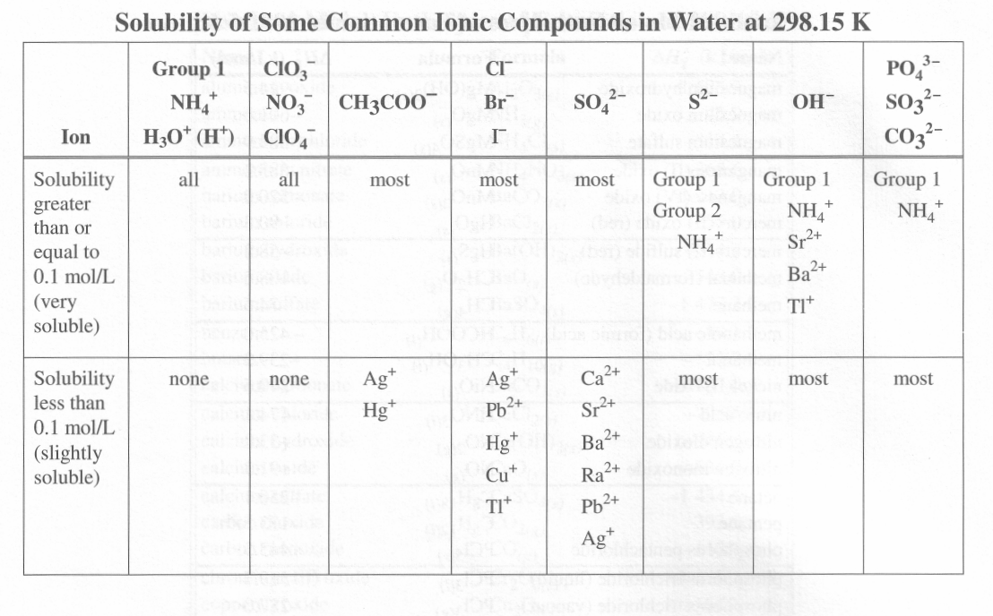

A solubility table of ionic compounds is best understood by assuming that most substances dissolve in water to some extent. The solubilities of various ionic compounds range from high solubility, like that of table salt, to negligible solubility, like that of silver chloride. The classification of compounds into high and low solubility categories **allows you to predict the state of a compound** formed in a reaction in aqueous solution. The cut-off point between high and low solubility is arbitrary (i.e. chemists can choose any number they like based on convenience). A solubility of 0.1 mol/L is commonly used in chemistry as this cut-off point because most ionic compounds have solubilities significantly greater or less than this value, which is a typical concentration for laboratory work. Of course, some compounds with intermediate solubility seem to be exceptions to the rule. Calcium sulfate, for example, has intermediate solubility, but enough of it will dissolve in water that the solution noticeably conducts electricity.

To determine whether a substance will dissolve well in water or not, we must use the **Solubility Table** and the following steps:

a) Find one of the ions in the compound along the top of the solubility table. (Usually it is the negative ion which is listed.)

b) Once you have found one of the ions along the, top, find the other ion in one of the rows underneath.

c) Look to the far left of the chart. If it says the combination is soluble, then write (aq) after the formula. If it says the combination is low solubility, then write (s) after the formula.

Determine whether a) hydrogen chloride, b)sodium carbonate, c) strontium hydroxide, and d) lead (II) iodide will be soluble in water.

**Hydrogen chloride**

a) Find, Cl– at the top of the table.

b) Look under it. The first box says “most” and the box underneath says Ag+, Pb2+, Hg+, Cu+. Since hydrogen is not specifically listed, it is included under the “most” category.

c) Look to the left of “most” and you will find “soluble”. This compound would dissolve well in water. Therefore, (aq) should be written after the formula.

HCl (aq)

**Sodium carbonate**

There are 2 ways to do this one:

a) Find CO32−. Below, sodium is a member of group 1. Look to the far left. This combination is soluble

b) Find sodium. It is a Group 1 element. Look underneath it. All ions that combine with sodium form soluble compounds.

Na2CO3 (aq)

**Strontium hydroxide**

Sr2+ is not found along the top but hydroxide (OH−) is. Sr2+ is listed in the row immediately under hydroxide. Look to the far left. This combination is soluble.

Sr(OH)2 (aq)

**Lead (II) iodide**

Again go through the sequence. It is low solubility.

PbI2 (s)

# Practice problems

1. Carbon tetrachloride will dissolve in gasoline. Would you expect carbon tetrachloride to dissolve in water?

2. Why would oil have a low solubility in water, but a high solubility in gasoline?

3. Use your solubility table to predict the solubility of the following:

sodium nitrate

ammonium sulfide

calcium sulfate

iron (II) hydroxide

barium sulfate

silver chloride

copper (I) bromide

copper (II) bromide

# Solubility and the principle of Dynamic Equilibrium

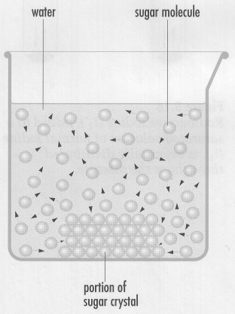Most substances dissolve in water to a certain extent, and then dissolving appears to stop. If the solution is in a **closed system**, one in which no substance can enter or leave, then observable properties (i.e. concentration and mass of undissolved solute) become constant. However, according to the kinetic molecular theory, particles are always moving and collisions are always occurring in a system, even if no changes in concentration or quantity of undissolved solute are observed. The initial dissolving of sucrose (C12H22O11), for example, in water is thought to be the result of collisions between water molecules and sucrose molecules that make up the sucrose sugar crystals. At equilibrium, water molecules still collide with the sucrose molecules at the crystal surface. Chemists assume that dissolving of the solid sucrose is still occurring at equilibrium. Some of the dissolved sucrose molecules must, therefore, be colliding and crystallizing out of the solution. If both dissolving and crystallizing take place at the **same rate**, no observable changes would occur in either the concentration of the solution or in the quantity of solid present. The balance that exists when two opposing processes occur at the same rate is known as **dynamic equilibrium**.

Dissolving, crystallization, and dynamic equilibrium between the two processes can be represented by chemical equations. In these equations, the relative lengths of the different arrows represents the relative rate of each process. Thus, when dissolving is occurring more rapidly than crystallization, the dissolving arrow is drawn longer than the crystallization arrow.

C12H22O11 (s)

dissolving

crystallizing

C12H22O11 (aq)

When crystallization is occurring more rapidly than dissolving, the crystallization arrow is drawn longer than the dissolving arrow.

C12H22O11 (s)

dissolving

crystallizing

C12H22O11 (aq)

And when both processes are occurring at the same rate, a dynamic (i.e. processes are still occurring) equilibrium results.

C12H22O11 (s)

dissolving

crystallizing

C12H22O11 (aq)

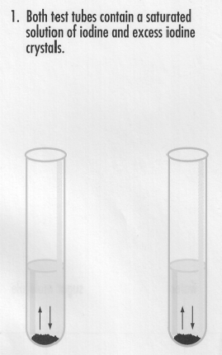However, as with all scientific theories, a theory is not acceptable unless there is empirical evidence that verifies the theory.

The theory of dynamic equilibrium can be tested by using a saturated solution of iodine in water. The picture to the right represents two test tubes containing saturated solutions of iodine in water.

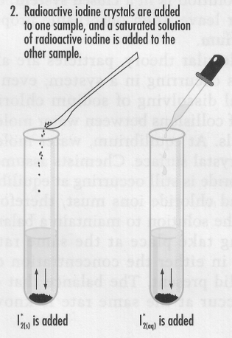

I2*(s) is added

I2*(aq) is added

Radioactive iodine (I2*) is used as a marker to follow the movements of some of the molecules in the solutions. The radioactive iodine emits radiation which can be detected by a Geiger counter to show the location of the radioactive iodine. To one sample of a saturated solution containing an excess of solid normal iodine, a few crystals of radioactive iodine are added. To a similar second sample, a few millilitres of a saturated solution of radioactive iodine are added. If the equilibrium were **static**, (i.e. the processes of dissolving and crystallization stop when saturation occurs) there would be no radioactive iodine detected in solution for the first test tube, and none would be detected in the solid iodine in the second test tube.

However, after a few minutes, the solution and the solid in both samples clearly show increased radioactivity. Assuming the radioactive iodine molecules are chemically identical to normal iodine, the experimental evidence supports the idea of simultaneous dissolving and crystallizing of iodine molecules in a saturated system. In other words, a **dynamic** equilibrium exists.

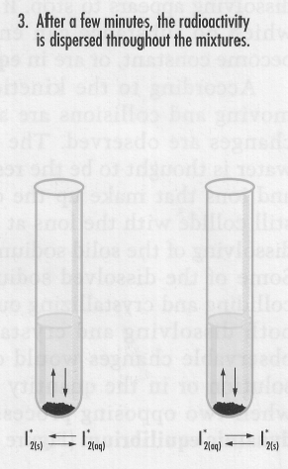

I2*(s)

I2*(aq)

I2*(aq)

I2*(s)

# Assignment

1. Classify the following solutions as solid, liquid, or gaseous solutions:

a) sugar and water

b) air

c) copper and zinc

d) carbonated beverage

e) alcohol and water

f ) table salt and water

2. What is an alloy?

3. Why are water and gasoline (C8H18) mutually insoluble?

4. Explain why iodine has a low solubility in water but high solubility in cyclohexane (C6H12)?

5. From the list below, select those substances which have good solubility in water and those that have good solubility in carbon tetrachloride:

Cl2 CH3OH C6H14 NH3 Br2 HCl

6. How does the solubility of CO2 in water vary with:

A. an increase in pressure of CO2 (g)? Explain your answer.

B. an increase in water temperature? Explain your answer.

C. a decrease in water temperature? Explain your answer.

7. How does the solubility of washing soda (Na2CO3) in water vary with:

A. an increase in pressure? Explain your answer.

B. an increase in temperature? Explain your answer.

8. Silver chloride is very low solubility in water. Will stirring increase the solubility of silver chloride in water? Explain.

9. Identify whether each of the following will be soluble or insoluble in water. Write out the formula and either (aq) or (s) after it.

|  |  |  |  |  |
| --- | --- | --- | --- | --- |
|  | Name of compound | Chemical Formula | Phase at STP | Soluble in water? |
| eg. | sodium chloride | NaCl(aq) | solid | yes |
| 1 | silver iodide |  |  |  |
| 2 | methanol |  |  |  |
| 3 | tin (II) phosphate |  |  |  |
| 4 | lithium sulphide |  |  |  |
| 5 | hydrogen carbonate |  |  |  |
| 6 | zinc hydroxide |  |  |  |
| 7 | sucrose |  |  |  |
| 8 | gold (I) bromide |  |  |  |
| 9 | lead (IV) acetate |  |  |  |
| 10 | calcium sulphate |  |  |  |
| 11 | ammonium hydroxide |  |  |  |
| 12 | aluminum sulphide |  |  |  |
| 13 | barium hydroxide |  |  |  |
| 14 | paraffin wax | C25H52 ( ) |  |  |
| 15 | mercury (I) carbonate |  |  |  |
| 16 | manganese (IV) bromide |  |  |  |
| 17 | iron (III) sulphite |  |  |  |
| 18 | antimony (III) sulphide |  |  |  |
| 19 | barium sulphide |  |  |  |
| 20 | ammonia |  |  |  |
| 21 | nickel (III) sulphide |  |  |  |
| 22 | francium thiosulphate |  |  |  |
| 23 | ammonium sulphide |  |  |  |
| 24 | lead (II) bromide |  |  |  |

10. What is a *saturated solution*?

11. What is a *supersaturated solution*?

12. What is *dynamic equilibrium*?

13. Give examples of two liquids that are immiscible and two that are miscible with water.

14. Can more oxygen dissolve in a litre of water in a cold stream or a litre of water in a warm lake? Include your reasoning.

15. State why you think clothes might be easier to clean in hot water.

16. Why do carbonated beverages go “flat” when opened and left at room temperature and pressure?

17. Write a balanced chemical equation to represent the simultaneous dissolving and crystallizing of sodium chloride for a saturated solution in contact with excess solute.

18. Give definitions for the following terms:

A. solubility (qualitative)

B. solubility (quantitative)

19. 40.0 g of KCl will dissolve in 200.0 mL of solution at 40oC. What is the molar solubility of KCl at 40oC?

20. To make concentrated hydrochloric acid requires that 45.2 g of HCl be dissolved to make 100 mL of solution at 25oC. What is the molar solubility of hydrogen chloride at 25oC?

21. If 35.7 g of sodium chloride dissolves to make 100 mL of a saturated solution at 0oC, what is the molar solubility of sodium chloride at 0oC?

22. The molar solubility of sucrose is 3.80 mol/L at STP. What mass of sugar is required to prepare 250 mL of a saturated sugar solution at STP?